Project Design Phase -||
Customer Journey Map

Date | 10 AUG2025
Team ID | PNT2025TMID12444
Project Name | Garage Management System
Maximum Marks

Customer Journey Map:
A customer journey map in a garage management system helps visualize the entire experience a customer goes through—from the moment they consider bringing their vehicle in, all the way to post-service follow-up. It's a fantastic tool for spotting pain points, improving customer satisfaction, and streamlining internal operations.
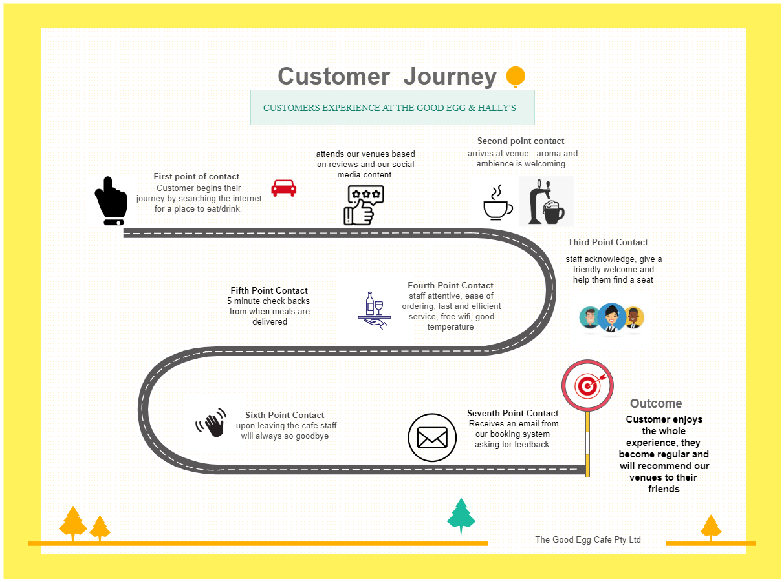

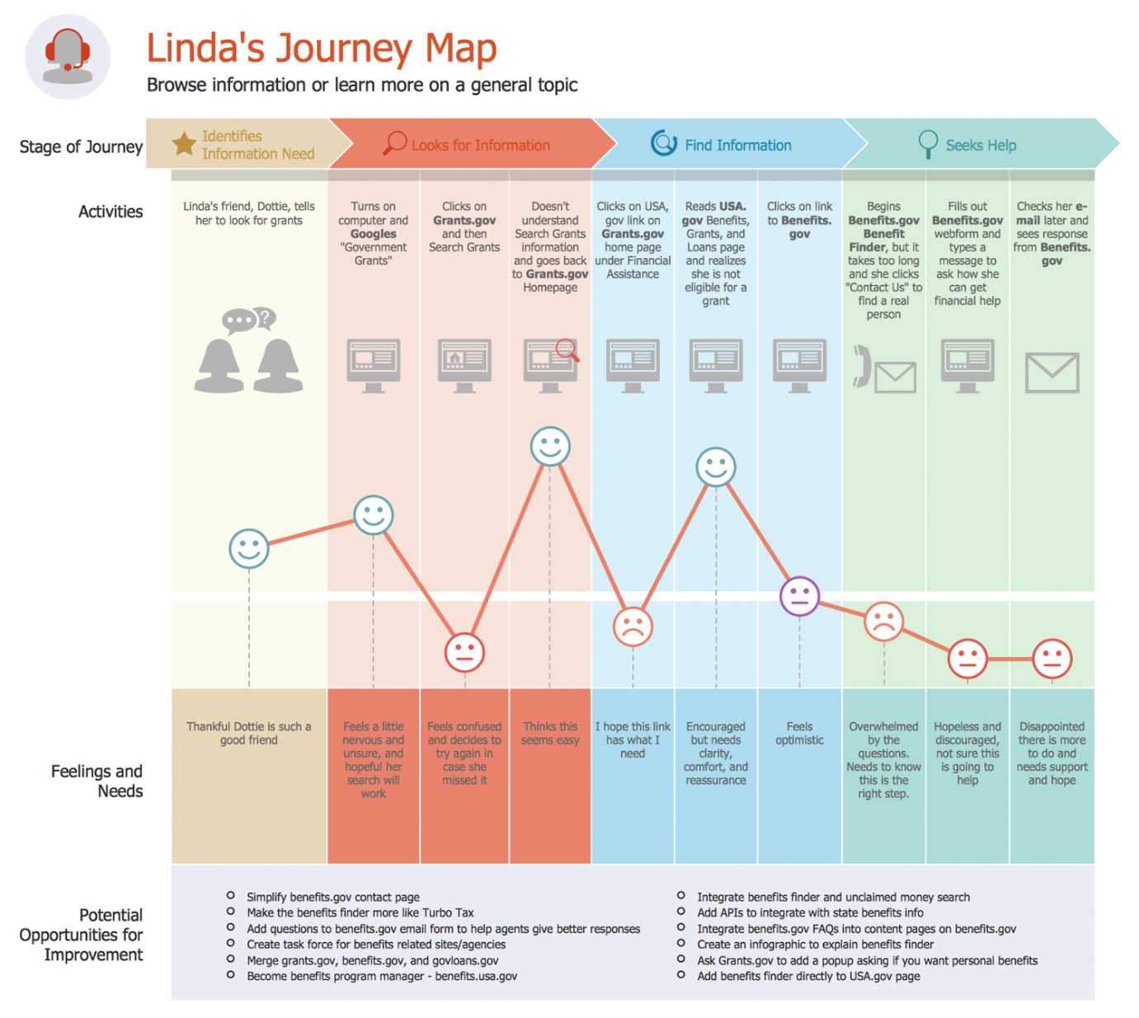

Essential Elements of a Customer Journey Map:

1. Customer Persona
- A fictional but realistic profile of your ideal customer
- Includes demographics, goals, challenges, and behaviors
2. Stages of the Journey
Common stages might include:
- Awareness: Customer becomes aware of your product or service
- Consideration: Research and comparison phase
- Purchase: Final decision and transaction
- Retention: Continued use and loyalty-building
- Advocacy: Recommending your brand to others
3. Customer Actions
- What the customer does at each stage
- Examples: browsing your website, reading reviews, contacting support
4. Emotions & Pain Points
- Emotional highs and lows throughout the journey
- Frustrations, confusion, satisfaction, or delight
5. Touchpoints
- Interactions between customer and brand
- Can include emails, ads, app usage, in-store visits, social media, etc.
6. Internal Processes
- What happens behind the scenes at each stage
- Helpful for aligning internal teams with customer experience
7. Opportunities for Improvement
- Gaps or friction points you can enhance
- New strategies to optimize experience and reduce churn

